**Basic Protype**

**Iteration #0**

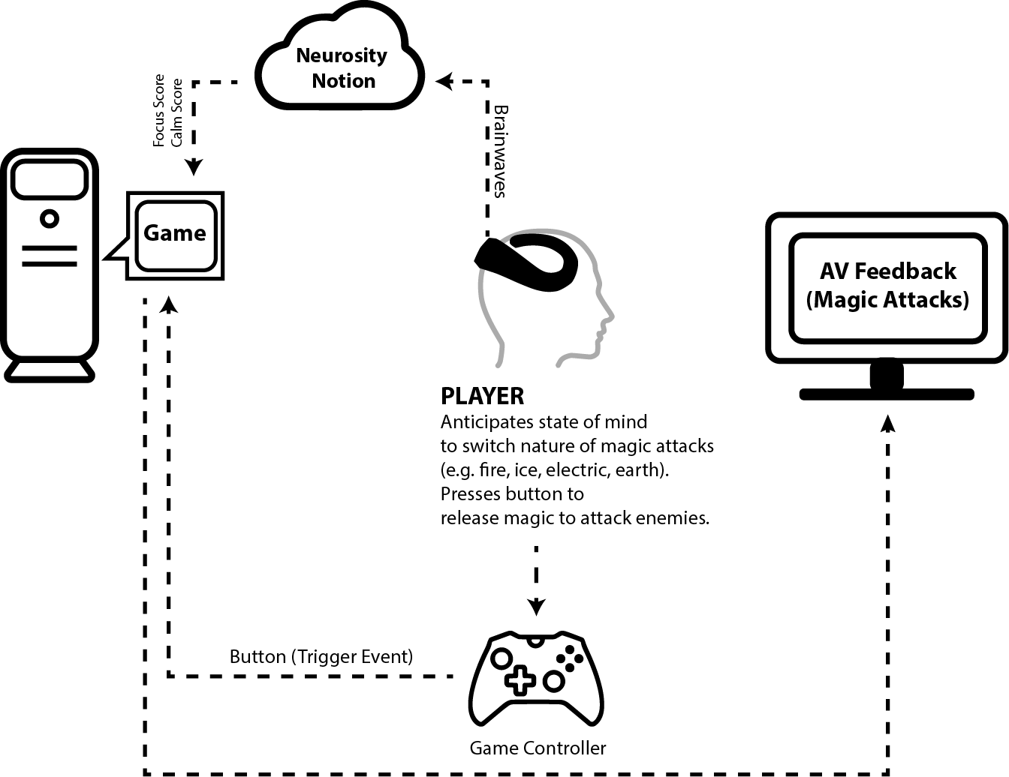

**Description**

Magic Bolts v0 is a neurogame wherein the player casts magic attacks by pressing a button and shifting into a state of mind congruous with the kind of spell to be cast (e.g. fury casts fire, calmness casts ice). The Neurosity Crown (EEG Device), connected to the WiFi, informs the game of the player’s focus and calm scores (float from 0 to 1), which is used to anticipate the type of spell to be cast (e.g. low calm scores plus high concentration scores will cast fire).

**Neural Congruence**

<(Semiotic) 1 2 **3** 4 5 6 7 (Engramic)>

Distribution of Agency

<(Egocentric) **1** 2 3 4 5 6 7 (Allocentric)>

**Journey through the UX**

**Iteration #1**

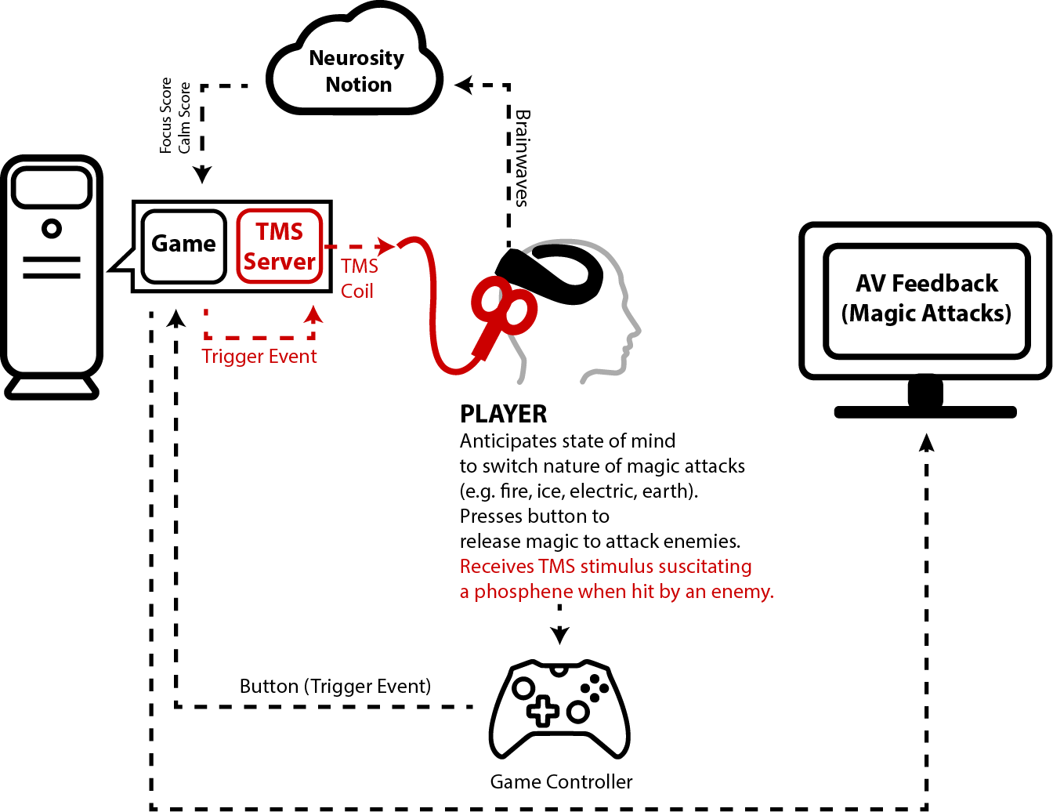

**Description**

Magic Bolts v1 is a neurogame wherein the player casts magic attacks by pressing a button and shifting into a state of mind congruous with the kind of spell to be cast (e.g. fury casts fire, calmness casts ice). The Neurosity Crown (EEG Device), connected to the WiFi, informs the game of the player’s focus and calm scores (float from 0 to 1), to anticipate the type of spell to be cast (e.g. low calm plus low concentration scores will cast fog). When hit, the player receives a TMS stimulus suscitating a phosphene as a form of feedback.

**Neural Congruence**

<(Semiotic) 1 2 3 **4** 5 6 7 (Engramic)>

Distribution of Agency

<(Egocentric) **1** 2 3 4 5 6 7 (Allocentric)>

**Journey through the UX**

**Iteration #2**

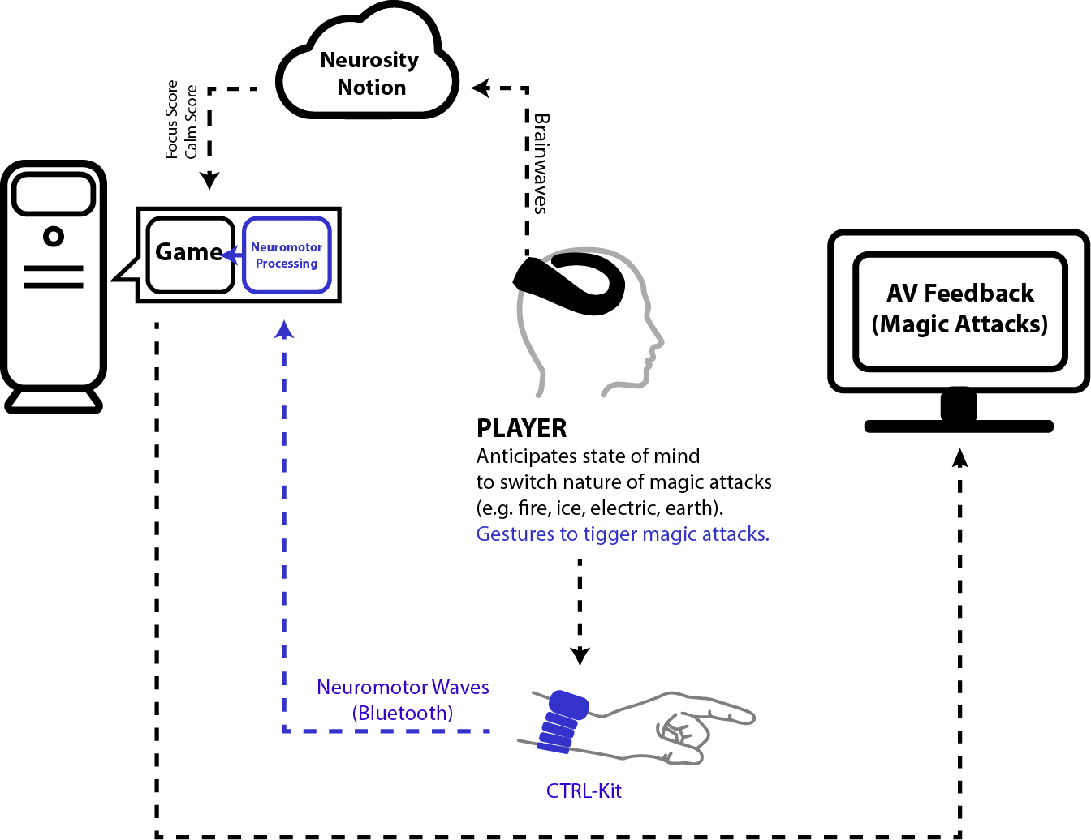

**Description**

Magic Bolts v3 is a neurogame wherein the player casts magic attacks by using a series of gestures while shifting into a state of mind congruous with the kind of spell to be cast (e.g. fury casts fire, calmness casts ice). The Neurosity Crown (EEG Device), connected to the WiFi, informs the game of the player’s focus and calm scores (float from 0 to 1), to anticipate the type of spell to be cast (e.g. high calm plus high concentration scores will cast ice). The (Meta) CTRL-Kit uses neuromotor waves to anticipate the gestural intention of the hands.

**Neural Congruence**

<(Semiotic) 1 **2** 3 4 5 6 7 (Engramic)>

Distribution of Agency

<(Egocentric) **1** 2 3 4 5 6 7 (Allocentric)>

**Journey through the UX**

**Iteration #3**

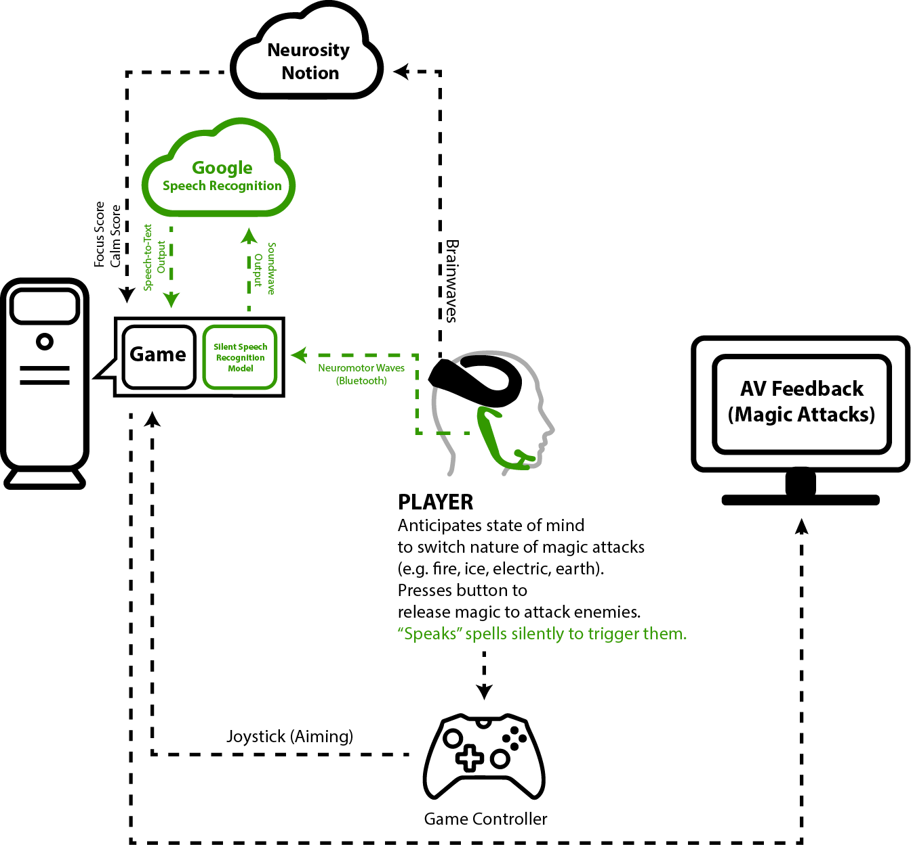

**Description**

Magic Bolts v4 is a neurogame wherein the player casts magic attacks by silently conjuring spells while concentrating to amplify the force of the attack. The Neurosity Crown (EEG Device), connected to the WiFi, informs the game of the player’s focus and calm scores (float from 0 to 1), to anticipate the force of the spell to be cast. The (MIT) AlterEgo, connected via Bluetooth, uses neuromotor waves to analyze the verbal intention, which is fed into Google Speech Recognition software to inform the game of the spell to cast.

**Neural Congruence**

<(Semiotic) 1 **2** 3 4 5 6 7 (Engramic)>

Distribution of Agency

<(Egocentric) 1 **2** 3 4 5 6 7 (Allocentric)>